

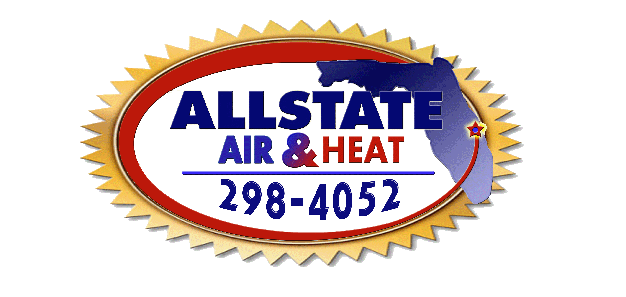
Allstate Air and Heat, Inc.
700 S. John Rodes Blvd. Unit D-4


Melbourne, FL 32904
321-298-4052
License #CAC1814555

ULTIMATE SERVICE AGREEMENT Residential
In consideration of the fee/fees listed below, it is understood by both the Homeowner and Allstate Air and Heat, Inc. that the Homeowner is entitled to and will receive the following under the provisions of this annual residential air conditioning and heating service agreement. Any combination of (2) below.

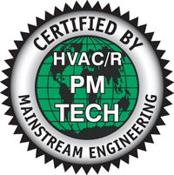
- One (1) 20 point air conditioning maintenance inspection/diagnostics.

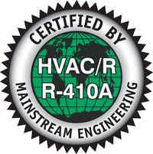

- One (1) 20 point heat safety inspection.



- Privileged Repair pricing with savings of 20%
- Cleaning of your condenser coil EVERY VISIT. ($55.00 discount)
- Cleaning of your Air Handler Blower wheel (when needed). ($55.00 discount)
- Prompt PRIORITY SERVICE to clients 24 HOURS a day
- Prompt, priority emergency service. NEVER ANY OVERTIME OR HOLIDAY CHARGES TO U.S.A. CLUB MEMBERS
- This agreement is guaranteed for a period of .(1). year from contract inception date below.
- Homeowner may schedule each inspection at his/her convenience. Allstate Air and Heat, Inc. will accommodate the Homeowner as best as possible.

Agreement includes one (1) A/C & Heating system $ 129.00
Additional units in same dwelling, $119.00 each | (#) of additional units: | ( ) x $119.00 = | $

TOTAL AGREEMENT………………………….……………………………...….….$ .00
Date of Inception: |  |  |  |  | Date of Termination:
 |  |  |  |  | Licensed by the Florida Dept. of Licensing and
HOMEOWNER |  |  |  |  | Regulation.
ADDRESS |  |  |  |  | Technicians Signature
CITY |  | STATE | ZIP |  | Customers Signature
HOME TELEPHONE |  |  |  |  | Date
Customer active email address:
*Homeowner allows Allstate Air and Heat, Inc. the right to contact homeowner by phone for preventative maintenance renewal and happy gram.

Customer Copy

Allstate Air and Heat, Inc.
700 S. John Rodes Blvd. Unit D-4

Melbourne, FL 32904
321-298-4052
License #CAC1814555

ULTIMATE SERVICE AGREEMENT Residential
In consideration of the fee/fees listed below, it is understood by both the Homeowner and Allstate Air and Heat, Inc. that the Homeowner is entitled to and will receive the following under the provisions of this annual residential air conditioning and heating service agreement. Any combination of (2) below.

- One (1) 20 point air conditioning maintenance inspection/diagnostics.
- One (1) 20 point heat safety inspection.

- Privileged Repair pricing with savings of 20%
- Cleaning of your condenser coil EVERY VISIT. ($55.00 discount)
- Cleaning of your Air Handler Blower wheel (when needed). ($55.00 discount)
- Prompt PRIORITY SERVICE to clients 24 HOURS a day
- Prompt, priority emergency service. NEVER ANY OVERTIME OR HOLIDAY CHARGES TO U.S.A. CLUB MEMBERS
- This agreement is guaranteed for a period of .(1). year from contract inception date below.
- Homeowner may schedule each inspection at his/her convenience. Allstate Air and Heat, Inc. will accommodate the Homeowner as best as possible.

Agreement includes one (1) A/C & Heating system $ 129.00
Additional units in same dwelling, $119.00 each | (#) of additional units: | ( ) x $119.00 = | $

TOTAL AGREEMENT………………………….……………………………...….….$ .00
Date of Inception: |  |  |  |  | Date of Termination:
 |  |  |  |  | Licensed by the Florida Dept. of Licensing and
HOMEOWNER |  |  |  |  | Regulation.
ADDRESS |  |  |  |  | Technicians Signature
CITY |  | STATE | ZIP |  | Customers Signature
HOME TELEPHONE |  |  |  |  | Date
Customer active email address:
*Homeowner allows Allstate Air and Heat, Inc. the right to contact homeowner by phone for preventative maintenance renewal and happy gram.

Contractor Copy

